Multi-Layer Perceptron (MLP)

A Multi-Layer Perceptron (MLP) is a type of feedforward artificial neural network. It consists of an input layer that accepts features, one or more hidden layers thar transform these features, and an output layer that produces predictions [1].
MLPs are fully connected networks, where each neuron in a layer is connected to every neuron in the next layer. They use activation functions, like ReLU or sigmoid, to model non-linear relationships and learn complex patterns from data [2]. MLPs are suitable for tabular data or flat, one-dimensional inputs.

Why MLP?
The choice of MLP for this task was motivated by [3]:
- Learning Versatility: MLPs can model non-linear relationships and are widely used for classification tasks.
- Simplified Data Representation: ECG images were flattened into one-dimensional vectors, aligning with MLP’s requirement for tabular inputs.
- Baseline Model: As a simpler model compared to CNNs, MLP provides a baseline for evaluating whether preserving spatial information is crucial for the dataset.

Algorithm
The MLP algorithm for classification involves the following steps:
- Data Preparation: Preprocess the images (resizing, normalization, flattening) and augment the training data
- Model Construction: Define input, hidden and output layers and applied activation functions (ReLU in hidden layers, and Softmax in the output layer for multiclass classification)
- Loss and Optimization: Use categorical cross-entropy as the loss function and optimize weights using the Adam optimizer
- Training: Forward propagate inputs through the network, calculate and backpropagate loss to update weights, and adjust weights iteratively to minimize loss
- Evaluation: Use accuracy and loss metrics on training and validation data and analyze the model’s performance using confusion matrix and classification reports.

Implementation
The following implementation steps were performed:
- Dataset Preparation
- Pixel values normalized between 0 and 1
- Applied PCA for dimensionality reduction
- Data augmentation applied (rotations, shifts, brightness, and noise)
- Class wights applied to address class imbalance
- Model Architecture
- Input layer: 256 neurons (after PCA)
- Hidden layers:
  - Layer 1: 256 neurons, ReLU activation, Batch Normalization, L₂ regularization
  - Layer 2: 128 neurons, ReLU activation, Batch Normalization, L₂ regularization
- Output layer: 4 neurons with Softmax activation for multiclass probabilities
- Training
- Loss function: Categorical Cross-entropy
- Optimizer: Adam with a learning rate of 0.0005
- Callback used: Early stopping and learning rate scheduler
- Evaluation Metrics
- Accuracy and loss for both training and validation sets
- Confusion matrix, classification report and ROC for detailed analysis

Results and Analysis
- Accuracy: The MLP model achieved a test accuracy of 62.05%, indicating that it performs moderately well on the test dataset.
- Training and Validation Metrics: To track model performance during training, the validation accuracy and loss was plotted as shown in Figure.
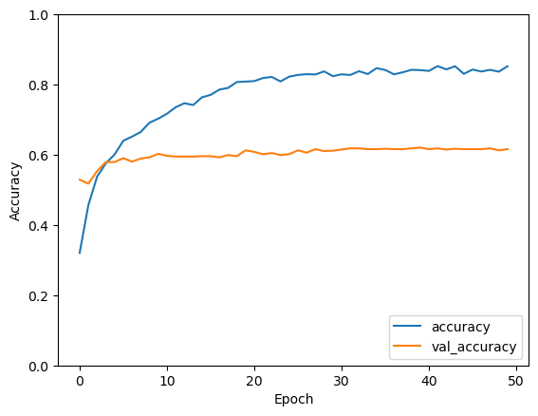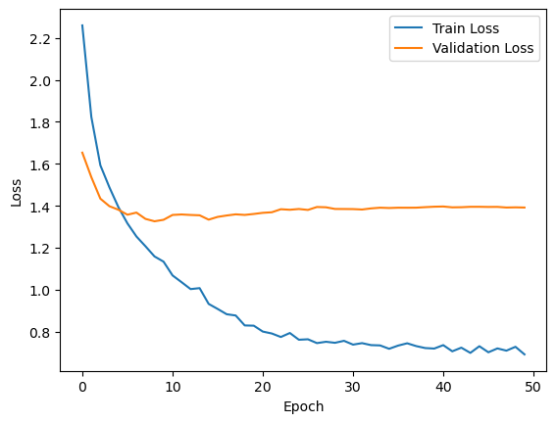
- Confusion Matrix: The confusion matrix visualizes the performance across different classes as shown in Figure.
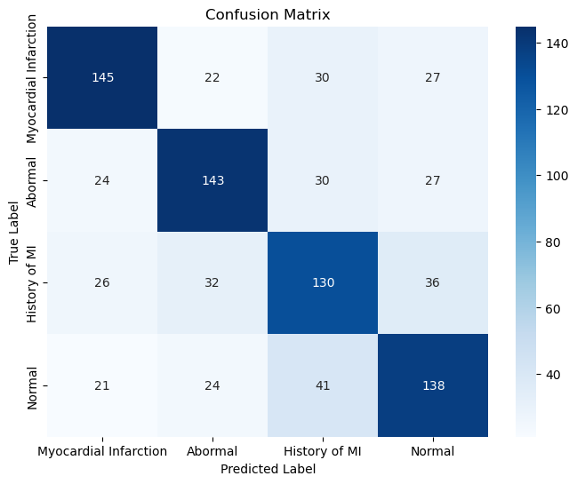
- Classification report: The classification report shows precision, recall, and F1-scores for each class as shown in Figure.
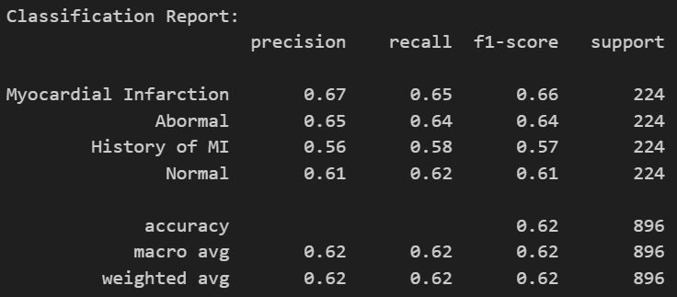
- ROC Curve Analysis: The ROC curve and AUC score confirm that the model is effective in distinguishing between different classes as shown in Figure, though there’s room for improvement.
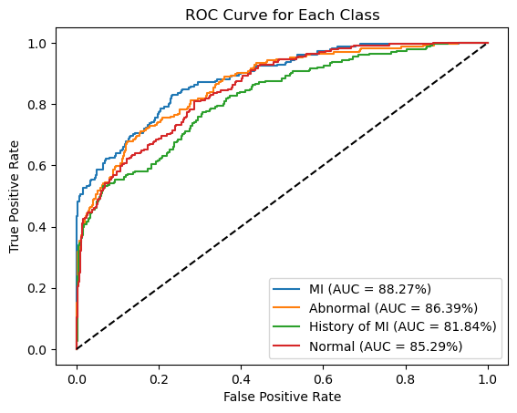

References
- Heidari, A.A., Faris, H., Mirjalili, S., Aljarah, I. and Mafarja, M., 2020. Ant lion optimizer: theory, literature review, and application in multi-layer perceptron neural networks. Nature-inspired optimizers: theories, literature reviews and applications, pp.23-46.
- Car, Z., Baressi Šegota, S., Anđelić, N., Lorencin, I. and Mrzljak, V., 2020. Modeling the spread of COVID‐19 infection using a multilayer perceptron. Computational and mathematical methods in medicine, 2020(1), p.5714714.
- Hartono, H., Sadikin, M., Sari, D.M., Anzelina, N., Lestari, S. and Dari, W., 2020. Implementation of Artifical Neural Networks with Multilayer Perceptron for Analysis of Acceptance of Permanent Lecturers. Jurnal Mantik, 4(2), pp.1389-1396.

